SOC Programming Hardware solutions

Objective
The purpose of this document is to document the process of determining possible solutions for programming the QPG6200L SOC, for QORVO_RADIO2_SD2, or future Qorvo Sponsored project

Solution 1:

From the QPG6200L Development kit “IoT Carrier Board Schematic” documents from Qorvo’s webpage we can find the associated Programming 10 pin header and appropriate connections.
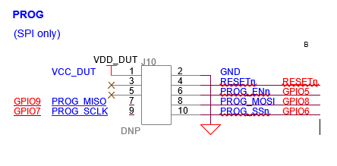
Figure 1: QPG6200L PROG Header

These connections were verified with the QPG6200L connection of the custom made PCB. The following Figures were also referenced from the QPG6200L Datasheet.

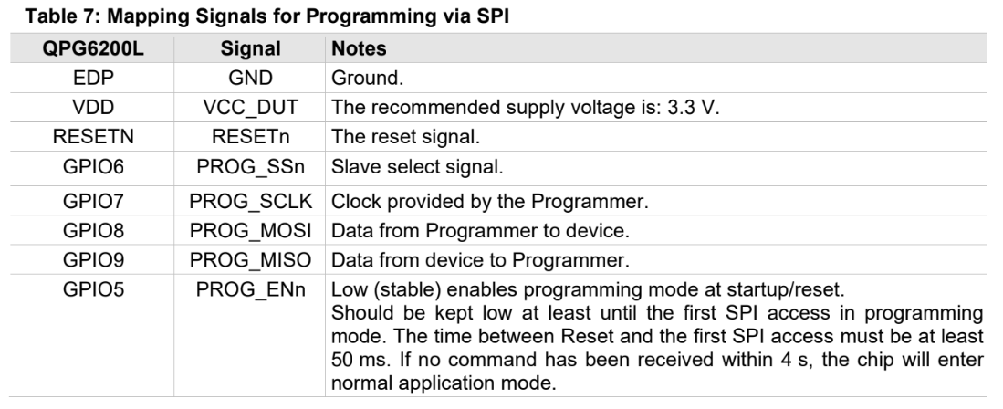
Figure 2: SPI Programming single table
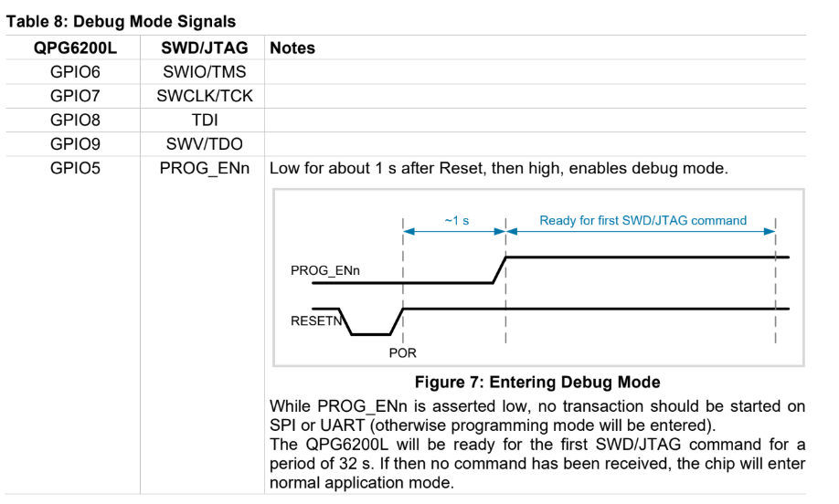
Figure 3: Debug single table

The current configuration, although designed for J-Tag, can currently be connected to a SPI connector. An alternative solution utilizing SPI over J-Tag is viable.

